Documento de Evidencias - AutomationPractice (CP02)
------------------------------------------------------------
Evidence: CP02_Click_ContactUs (20260115_171614)
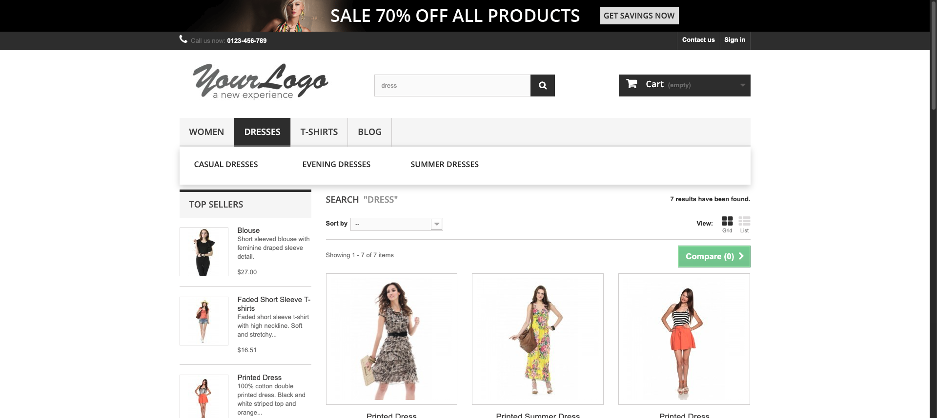
------------------------------------------------------------
Evidence: CP02_Before_Send (20260115_171616)
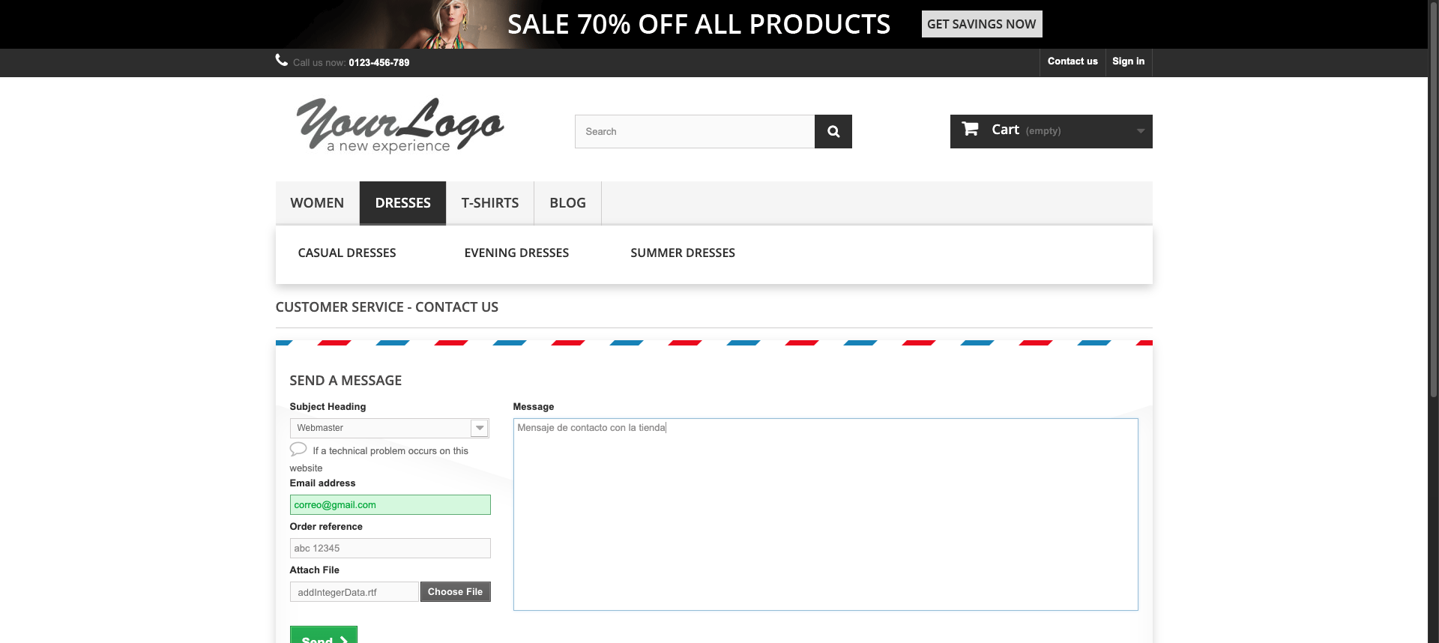
------------------------------------------------------------
Evidence: CP02_After_Send (20260115_171617)
